Power Drama School
Enrolment Policy
Power Drama School enrols children three times per year at the start of terms in September, January and April.
- Enrolment is open to all children between the age of 5 and 18.
- Fees for terms must be paid on the first day of term.
- Parents must complete and sign a registration form before students commence in class.
- Power Drama School classes are open to all children regardless of race, nationality, ethnic group, gender, religious or cultural backgrounds.
Code of Conduct
Our code of conduct (behaviour) helps us to ensure that everyone at Power Drama School can learn in a creative, supportive environment that is safe and free from harm.
Our teachers promise to encourage every student to reach their full potential, to treat all students fairly and with respect. Our code of conduct will be taught to all students attending classes.
Respect for Students/Staff/Property
- All members of Power Drama School will be polite and courteous to each other at all times.

- Students are asked to listen to the instructions of their teachers during class.

- All students are asked to have respect for Saint Macullins Centre and any theatre/performance space we will use during the year. This means that students will not damage the property in any way during classes/performances

- Students are asked to respect Power Drama School equipment while at classes – CD player, IPod, Props, Costumes etc

- Students are expected to tidy up after themselves and are responsible for bringing their belongings home after class.
Anti- Bullying Policy
All students have the right to enjoy classes and develop their full potential in class.
At Power Drama School we do not allow bullying.
Bullying can be someone:
- Calling people names or saying hurtful things.
- Swearing at you.
- Pushing you around.
- Hurting your body in any way, such as pushing, pinching,
punching or kicking you. (Physical abuse)
- Leaving you out or ignoring you. (Emotional abuse)

Cyberbullying

What Is Cyberbullying?
Cyberbullying is bullying that takes place over digital devices like mobile phones, computers, and tablets. Cyberbullying can occur through SMS, Text, and apps, or online in social media. Cyberbullying includes sending, posting, or sharing negative, harmful, false, or mean content about someone else. It can include sharing personal or private information about someone else causing embarrassment or humiliation.
The most common places where cyberbullying occurs are:
Social Media, such as Facebook, Instagram, Snapchat, and Twitter
We do not allow Cyberbullying at Power Drama School.

Mobile Phone Use
- We do not allow the use of mobile phones during class time. Students may only use their own phone to phone or text parents/guardians with prior permission from the teacher.

Information on our Child Protection Policy for Parents/Guardians

Here at Power Drama School we are committed to providing a safe environment for children and young people. Children’s welfare and safety is our top priority. We comply with Children First: National Guidelines for Child Protection and Welfare. To help us achieve this, we have a Child Protection Policy and Procedures which guide our work.

Parents/guardians are children’s primary carers. We work in partnership with parents/guardians to ensure children’s safety and enjoyment of the activities we offer. We ask you to take some time to read our guidelines and programme information. If you have any questions or concerns you can talk to Loraine Power; our Designated Person for Child Protection.

Here are some questions you might want to ask:

What is a child protection policy?
A child protection policy is a statement of the organisation’s commitment to keep children and young people safe and to report any concerns about their welfare. The policy will contain procedures for how this is done in the organisation.
These will usually include:
- A code of behaviour for staff.
- A safe recruitment policy.
- A Designated Person who deals with child protection issues.
- Procedures for reporting concerns to the HSE.
- Procedures for dealing with allegations against staff or volunteers.
- A confidentiality policy.
- A complaints policy.
- An accidents and incidents reporting policy

What should I expect from an activity or group my child takes part in?
- You can expect your child’s safety and welfare to be the top priority.
- You will be informed about and asked to give your consent for all activities your child is involved in.
- You will be asked for some personal information, such as contact details and any health information which is relevant for your child.
- You can expect that members of staff are carefully selected and suitable to work with children and young people.

What does confidentiality mean?
- Confidentiality means that information in relation to you or your children will only be shared with people who ‘need to know’.
- Personal information about your family will be treated with respect and records will be securely stored.

Who does the organisation report to, if they have a child protection concern about a child or young person?
- If we have a child protection concern about a child we are obliged to report it to a Duty Social Worker in the Health Service Executive (HSE), or in an emergency, to An Garda Síochána.
- Reckless endangerment of children is a criminal offence under Irish law which could result in criminal prosecution and imprisonment for failure to comply with the relevant provisions of the appropriate legislation.

What information will be passed on?
- We will pass on the child’s name, address and age, your name and address and will say what the reason for concern is.
- We will also include the name of the person making the report.
- Anyone making a report of suspected child abuse, provided they act ‘reasonably and in good faith’ will have immunity from civil liability (Protection for Persons Reporting Child Abuse Act, 1998).

Do I have a right to see information about me or my child?
- Yes. You have a right to see any records that are kept about you or your children.

Is there a code of behaviour for staff, children and young people,
volunteers, parents?
- Yes. A code of behaviour for staff, including volunteers, is part of our child protection policy.
- We have a code of behaviour for children and young people.
- We have an anti-bullying policy.
- We also ask parents/guardians to comply with certain measures to ensure their children’s safety (see below).

Who can I talk to if I have a concern about a child?
- If you have a concern about a child or young person, you can talk to Loraine Power our Designated Person. She will listen to your concern and explain our Child Protection Policy to you.
- Alternatively, you can contact a Duty Social worker in the HSE directly (contact details for local area Duty Social Worker).

Is there a complaints policy? Who can I talk to if I have a complaint?
- Yes, we have a complaints policy.
- If you have a complaint you can talk to or e-mail Loraine Power (powerdramaschool@hotmail.com). We will endeavour to respond to your complaint within forty- eight hours.

Are staff vetted by the Gardaí and are references checked for all staff and volunteers?

Yes, all teachers are Garda Vetted to work with children. References are checked for all staff.

Can I come and visit or stay and watch the activities if I want to?

- Yes. You are always welcome to visit. Sometimes when children/young people are rehearsing for a show they may prefer their parents wait and see the show on stage rather than at rehearsals but you and your child/children can decide which you would prefer to do

Collection Policy/Parents’ Co-operation

In order to help ensure children and young people’s safety and welfare we ask parents to:

- Bring and collect children on time for class. Staff at Power Drama School, are not responsible for children outside of scheduled class times.
- If your child has permission to walk home alone after class or if another adult has permission to collect your child please let us know.
- Give us any relevant information you think it is important for us to know in order to ensure your child’s safety, happiness and wellbeing. (Eg: medical requirements of the child, ability to participate in activities – any difficulty in reading, speaking, concentrating etc, emergency contact details.)
- Follow directions of staff when requested.
- Complete and sign registration and consent forms for
classes as requested.
- Ensure your child wears comfortable clothes and footwear to classes and rehearsals.
- Ensure your child brings all of his/her belongings home at the end of class.
- Encourage your child to prepare for class each week (learning any lines or lyrics required etc)

Your co-operation is much appreciated & we hope all students
have a great experience at Power Drama School

FIRE EVACUATION PROCEDURES
1. In the event of the fire alarm going off, all students and staff must evacuate the building and head to the nearest fire exit leaving coats, bags etc., behind.
2. There are two fire escapes in the building, please use Exit 1 unless it’s not safe to do so – Exit 1) the wheelchair entrance to the hall which is to your left as you stand facing the stain glass windows (stage) in Saint Macullins Hall and Exit 2) There is an exit in the foyer where the kitchen and toilets are located. The key for this exit is always left on the teacher table in the hall and is clearly visible.
3. One teacher must take the class register with them while the other teacher checks the toilets.
4. On exiting the building everyone must go to the designated fire assembly point which is marked with a yellow X on photo.
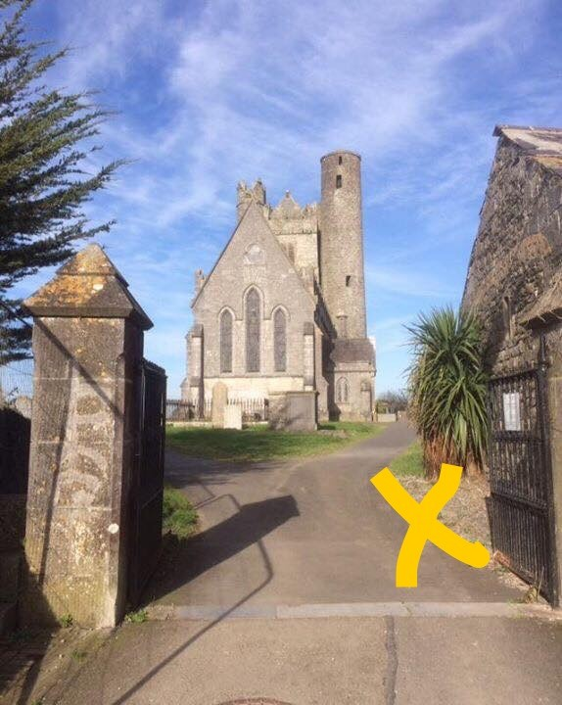

5. Teachers will ensure all students are present.
6. If students are missing please inform the Fire Safety Officer (Loraine Power) who will take the necessary action. If the Fire Safety Officer is not available please inform Susan Kenny or Lynn Cassidy.
7. Do not return to the building until the all clear signal has been given by the Fire Safety Officer.

